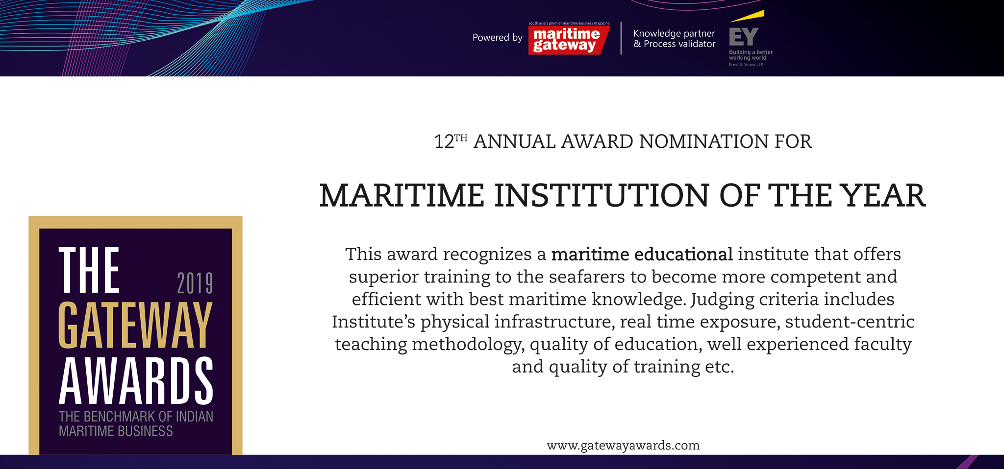

Please fill your responses and mail it to the address mentioned at the end of the Questionnaire

Note: All information and data should be provided for the FY 2018-19. In case, if you are unable to provide FY 2018-19 data, CY2018 information can be sent with a reason for not providing data for FY 2018-19.

Contact information:

Name of the Organization

Contact Person

Designation

Contact no.

Official Email ID

Address

When the institute was established (year)

Educational Service Offerings

 | Parameters | Units | Inputs
 | Training facilities  (laboratories, equipment like  simulators, etc) | • Quantitative + qualitative  inputs
 |  | on infrastructure facilities
 |  | • Word limit ~ 200 words
 | Quality of training  (Institute’s dedication and integrity in shaping cadets of the highest order, excellence in maritime training, student-centric teaching methodology,  etc.) | • Quantitative
 |  | • Word limit ~ 200 words
 | Quality of faculty  (min., max and average years of experience, qualifications, industry relationships, career achievements and innovative approaches in teaching) | • Word limit ~ 200 words
 | Contribution to the  industry  (some examples of contributions by institute’s faculty and/or students in promoting innovation or other dimension in the maritime industry – something  that may have helped the maritime industry improve efficiency or rationalize processor increase turnover or any other reasonably strong impact) | • Word limit ~ 200 words

Performance Indicators

Parameters | Type of inputs needed | Inputs
Placements Record | • Qualitative, substantiated by quantitative facts
Recognition | (beyond Directorate General of Shipping)
Highlights of
the year

Please use below contact for sending filled-in form and also for any queries.

Rakesh Oruganti | Cell: +91 99483 34568;E mail ID: rakesh.oruganti@gatewaymedia.in

